COMMENT FORM
THE FSC INTERIM FOREST STEWARDSHIP STANDARD FOR LIBERIA, DRAFT 1,

Public Consultation: From 20 February 2024 to 20 April 2024

You can also provide your comments online through the link below or scan the QR
https://forms.office.com/r/fABbBPnPqC?origin=lprLink
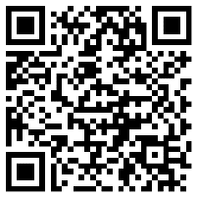

Draft  1 | Consultation  First Public | Comments contact  oseijw@gmail.com

Name: Click or tap here to enter text.
Forest Management Interest Choose an item.
Email: Click or tap here to enter text.
Reference indicator/sub-indicator/Principle or Annex | Your Comment  (Your rationale or justification for change) | Your Proposed change  (Your suggested modifications, new wording, deletions etc.) | TWG Response & justification
You can add more rows if you have more comments.

